ITALIAN RIVIERA TOUR
From MILAN
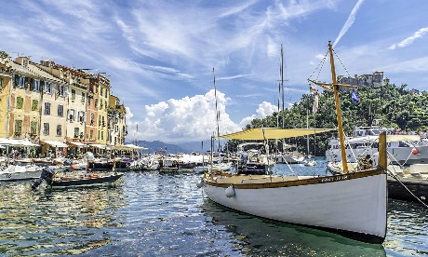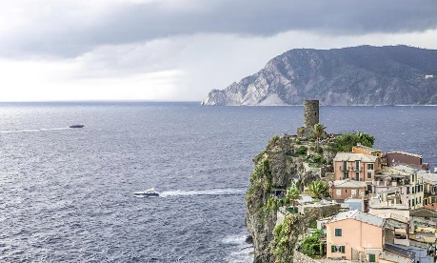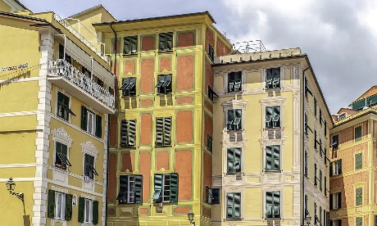
Cod. 002MIEN
Day 1) MILAN – GENOA (140 km)

Departure at 08.30 am from Milan to Genoa (departure is also possible directly from Genoa joining the group at 10.45). Visit of this seaport, one of the largest of the Southern Europe, the first in Italy; 6th city of the country, this town has an important history, as a Maritime Republic. Its historical centre has grown around the dock, is full of narrow and characteristic streets and has a medieval origin. Continue to the modern zone of “Ancient Port”, restored for the 500 years of America discovery by Christopher Columbus. Here we find the Aquarius, the second biggest in Europe. Lunch at your own. Accommodation in hotel and evening for personal interests. Overnight at the hotel.

Day 2) GENOA – RAPALLO (30 km) - SANTA MARGHERITA (3 km) – PORTOFINO (5 km) – GENOA (40 km)

Breakfast at the hotel. Today you will be invited to taste focaccia, a typical local kind of bread in both versions, regular and with cheese. Departure to Rapallo, famous tourist centre. Visit of the old town where a long promenade ends with the beautiful castle of Dragut. Then, road to Santa Margherita, beautiful seaside city of Riviera di Levante (Eastern Riviera), located in the Tigullio Gulf. Lunch at your own. In the afternoon, visit of Portofino. Around a little square, you can have a nice view of a group of high, coloured and picturesque houses. In the small port, during the high season, you can see expensive yachts from every part of the world. Finally, return to Genoa with a panoramic road. Overnight at the hotel.

Day 3) GENOA – the eastern coast: PORTOVENERE (110 km) – CINQUE TERRE (10 km) – GENOA (90 km)

Breakfast at the hotel and departure to Portovenere, a fishermen village located at the end of La Spezia Gulf. Visit. Ferry to Cinque Terre (if the atmospheric conditions doesn’t permit the boarding, the visit will be with a panoramic itinerary by bus/minivan and train.) Heritage of the Unesco, these 5 fishermen villages, symbolize a group unique in the world for its beautiful landscape and the medieval style of their buildings. Visit of the little village of Vernazza and Monterosso, the biggest of the five villages, characterised by long beaches and narrow streets full of restaurants and handcraft shops. Lunch at your own. In the afternoon coming back to Genoa. Overnight at the hotel.

Day 4) GENOA – the western coast: VARAZZE (40 km) and finalborgo (40 km) – milan (190 km)

Breakfast at the hotel and outgoing to the western coast of Liguria. Arrival to Varazze, a picturesque and little village of fishermen with its nice corners and small beaches. Visit. Later, departure to Finalborgo, a typical medieval village at the bottom of the mountains where the Alps meet the Apennines. Lunch at your own. Return to Milan. End of services.

- Tour starts and finishes at Starhotels Anderson, Piazza Luigi di Savoia 20, Milan. Please contact us for any further information concerning transfers or additional service.

RATES PER PERSON:

 | COMFORT |  | LUJO
ITALIAN RIVIERA 2026 | PRECIO PÚBLICO EN DBL | PRECIO PÚBLICO EN SGL | PRECIO PÚBLICO EN DBL | PRECIO PÚBLICO EN SGL
SHOULDER SEASON 2026 = 19/02 – 02/03 – 19/03 – 02/04 – 09/04 – 13/04 – 27/04 | € 1,560 | € 1,840 | € 1,610 | € 1,950
HIGH SEASON 2026 = 14/05 – 28/05 – 08/06 – 22/06 – 06/07 – 23/07 – 20/08 – 05/10 – 19/10 – 29/10 – 12/11 – 23/11 | € 1,650 | € 2,010 | € 1,690 | € 2,090
TOP SEASON 2026 = 03/09 – 14/09 – 24/09 | € 1,690 | € 2,110 | € 1,740 | € 2,210

IN THE TOWN OF GENOA A CITY TAX FOR ACCOMMODATION IS NOW COMPULSORY. EVERY CLIENT MUST PAY IT CHECKING OUT.
RATES INCLUDE:
- Itinerary as above according to the hotel option choice
- Bus at disposal for the mentioned itinerary
- English speaking escort guide/driver up to 8 people (driver and guide with more than 8)
- Cruise by boat at the Cinque Terre (in case of bad conditions of weather, the excursion will be by bus/minivan and panoramic train)
- Local guide in Genoa and Cinque Terre
- Audioguide during the cruise at the Cinque Terre
- Focaccia and Focaccia with cheese tasting
- Free Wi-fi on board

RATES DO NOT INCLUDE:
Meals, drinks, entrances, porterage, city taxes, tickets, tips extras and whatever not specified in “RATES INCLUDE”.

DATES OF DEPARTURE:

19/02/2026
02/03/2026
19/03/2026
02/04/2026
09/04/2026
13/04/2026
27/04/2026
14/05/2026
28/05/2026
08/06/2026
22/06/2026
06/07/2026
23/07/2026
20/08/2026
03/09/2026
14/09/2026
24/09/2026
05/10/2026
19/10/2026
29/10/2026
12/11/2026
23/11/2026

IMPORTANT NOTES:

During the season from Novembre to March, departures will be guaranteed with a minimum of 4 pax.

Between November 1st and March 31st, the ferry service at Cinque Terre does not work. The itinerary will be by bus/minivan between La Spezia and Manarola (in place of Portovenere) and by train from Manarola to Monterosso via Vernazza.

During the season from April to October), the ferry services are always achieved when the weather conditions permit them. In case this condition cannot be respected, the same activity will be replaced with the winter alternative as specified above.

HOTELS ACCOMMODATION OR SIMILAR – COMFORT TOUR:

GENOA: Hotel Best Western City Plus****, Via di San Sebastiano 6, Tel. +39/010 584707, https://www.hotelcitygenova.it/

HOTELS ACCOMMODATION OR SIMILAR – LUXURY TOUR:
GENOA: Hotel Best Western City Plus****, deluxe room, Via di San Sebastiano 6, Tel. +39/010 584707, https://www.hotelcitygenova.it/

CANCELLATION POLICY:
- 100% no-show
- 70% from 1 to 3 days before the departure
- 50% from 3 to 14 days before the departure
- 30% from 14 to 21 days before the departure

