DOLOMITES TOUR
From MILAN

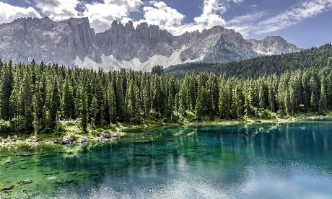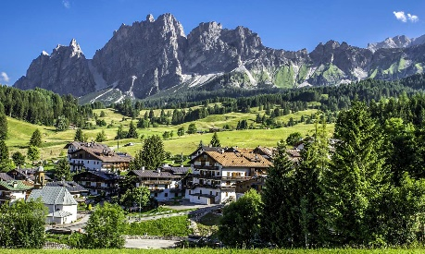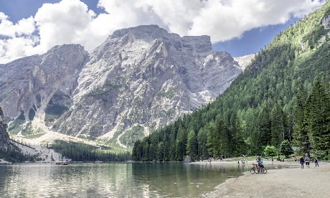
Cod. 003MIEN

DAY 1) MILAN - VERONA (140 km) - VAL DI CADORE (200 km) - PIEVE DI CADORE (30 km) - CORTINA D'AMPEZZO (30 km)
Departure at 08.30 am from Milan (departure is also possible directly from Verona at Hotel Mastino, joining the group at 10.30). Outgoing to Verona having a short break to discover this beautiful city. A walk through its narrow streets allows us to get in touch with its varied and fascinating past: traces of its splendid Roman origins, its prevailing medieval structure dating back to the time of knights and castles, its magnificent Renaissance palaces as well as the impressive fortifications which protect it. A suggestive blend of art and history which continuously fascinates the onlooker. We will visit Piazza Bra with the Arena, a Roman amphitheatre, Via Mazzini, Piazza delle Erbe e dei Signori with the monument to Dante Alighieri and Juliet’s Balcony. Lunch on your own. Next, departure to Cortina d’Ampezzo (Departure is also possible in front of the train station of Venice Mestre at 3 pm). The journey will be around Val Cadore among sinuous mountains and little villages that show the history of the territory, the tradition of the craftsmanship and offer good food and a lot of local museums. Visit on the way to Cortina of the centre of Pieve di Cadore, capital of the glasses industry and birthplace of the great painter Tiziano Vecellio. Arrival to Cortina d’Ampezzo, probably the most renowned one because of its historical importance in Italian summer and winter holidays since the 1950’s, is in the middle of the large valley of Boite. Cortina is not only a tourism resort but also the centre of traditional works, as for example, wood manufacturing. Overnight at the hotel.

DAY 2) CORTINA - LAKE MISURINA/TRE CIME DI LAVAREDO (15 km) – LAKE DOBBIACO (18 km) – PUSTERIA AND BADIA VALLEYS (75 km) – FALZAREGO PASS (15 km) - CORTINA (15 km)
Breakfast at the hotel. Outing to Lake Misurina (situated in a perfect position among woods and Dolomites tops, Three peaks of Lavaredo the most important ones, probably one of the best places for alpinism experts). Then, way to Lake Dobbiaco, with a strange and shining colour emerald of its water that makes it as unique in the world. Visit of Val Pusteria and Val Badia, probably the most typical valleys of the region, having a stop in a village to have lunch at your own. After that, we will cross Falzarego Pass coming back to Cortina, in order to have free time for the rest of the day. Overnight at the hotel.

DAY 3) CORTINA - PASSO FEDAIA (45 km) - MARMOLADA (3 km) - CANAZEI (15 km) - LAKE CAREZZA (25 km) - MERANO (55 km) - BOLZANO (30 km)

Breakfast at the hotel. Today you will be invited to taste the flavourful speck, a kind of smoked ham, typical of the Dolomites valleys. Departure to Canazei through Fedaia Pass; arrival to the bottom of the Glacier of Marmolada, the highest glacier of the eastern Alps. Visit of Canazei, an important place for tourism in all seasons, due to the wonderful view given by this part of Dolomites that receives thousands of tourists every month. Through Passo Costalunga, we arrive at Lake Carezza. Stop having a look at this wonderful lake. Then, departure to Merano, the second biggest city of the province after Bolzano. Famous worldwide for its Christmas market, Merano is also a charming and amazing cultural and historical centre. Visit the old town and have lunch on your own. Second half of the day is dedicated to Bolzano. Important commercial centre in the Middle Age, it has increased its industry productions during the World War. Tourism still represents the first resource of the local economy. Visit of Duomo: the Cathedral, with a gothic style, is considered as the symbol of the town; finally, we’ll visit the main central streets, as Via dei Portici, core of the Medieval town. Rest of the evening is free for your personal visits. Overnight at the hotel.
DAY 4) BOLZANO – ROUTE OF THE WINE (30 km) – TRENTO (40 km) - MILANO (220 km)
Breakfast at the hotel. Departure to Trento, capital of the region through the so called Weinstrasse, the route of the wine, where small villages like Caldaro or Trameno offer relaxing and amazing views. Short stop for visiting the area. Arrival to Trento. The city is dominated by the castle, known as del Buon Consiglio, symbol of the House of Habsburg which dominated the district for many centuries. Santa Maria Maggiore, built in the XVI century and one of the first work of Renaissance and Gothic age; Palace Geremia, building that represents the XVI century and Piazza Duomo with the beautiful Cathedral of Saint Vigilius. Lunch at your own. Departure to come back to Milan. End of the services.
Tour starts and finishes at Starhotels Anderson, Piazza Luigi di Savoia 20, Milan. Please contact us for any further information concerning transfers or additional service.

RATES PER PERSON:

 | COMFORT |  | LUXURY
2026 DOLOMITES | DBL | SGL | DBL | SGL
2026 SHOULDER SEASON: 23/04 – 07/05 – 21/05 – 04/06 – 01/10 – 15/10 | € 1,490 | € 1,780 | € 1,910 | € 2,490
2026 TOP SEASON: 18/06 – 02/07 – 16/07 – 30/07 – 27/08 – 10/09 | € 1,610 | € 1,930 | € 2,030 | € 2,750

IN THE TOWNS OF CORTINA AND BOLZANO A CITY TAX FOR ACCOMMODATION IS NOW COMPULSORY. EVERY CLIENT MUST PAY IT CHECKING OUT.

RATES INCLUDE:
- Bus at disposal for the mentioned itinerary
- English speaking escort guide/driver up to 8 people (driver and guide with more than 8)
- Red and green Dolomites apples tasting
- Speck (a typical Dolomites smoked ham) tasting
- Free Wi-Fi on board

RATES DO NOT INCLUDE:
Meals, drinks, entrances, porterage, city taxes, tickets, tips extras and whatever not specified in “RATES INCLUDE”.

DATES OF DEPARTURE:

23/04/2026
07/05/2026
21/05/2026
04/06/2026
18/06/2026
02/07/2026
16/07/2026
30/07/2026
27/08/2026
10/09/2026
01/10/2026
15/10/2026

IMPORTAN NOTE:
The itinerary may vary in case of bad weather conditions; unless the safety of the passengers was in danger, all places will be visited at all.

HOTELS ACCOMMODATION OR SIMILAR – COMFORT TOUR
CORTINA D'AMPEZZO: VILLA NEVE 3***S, Via Franchetti 18, Tel. +39/0436 2228, http://www.hotelvillaneve.com/
BOLZANO: PARKHOTEL LAURIN**** CLASSIC ROOM, Via Laurino 4, Tel. +39/0471 311000, http://www.laurin.it/it/

HOTELS ACCOMMODATION OR SIMILAR – LUXURY TOUR:
CORTINA D'AMPEZZO: HOTEL AMBRA**** classic ROOM, Via XXIX Maggio 28, Tel. +39/0436 867344, http://www.hotelambracortina.it/
BOLZANO: PARKHOTEL LAURIN**** SUPERIOR ROOM, Via Laurino 4, Tel. +39/0471 311000, http://www.laurin.it/it/

CANCELLATION POLICY:
- 100% no-show
- 70% from 1 to 3 days before the departure
- 50% from 3 to 14 days before the departure
- 30% from 14 to 21 days before the departure

