FRENCH COAST TOUR
From MILAN
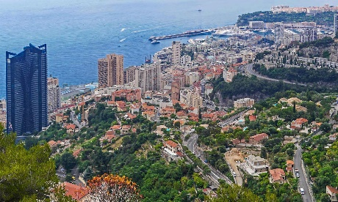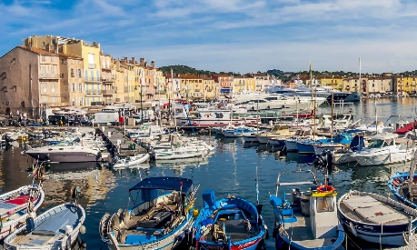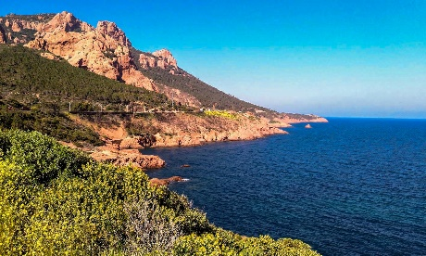

Cod. 004MIEN

Day 1) MILAN – finalborgo (190 km) – MONACO (110 km) – NICE (30 km)

Departure at 08.30 am from Milan to the western coast of Liguria. Arrival to Finalborgo, a typical medieval village at the bottom of the mountains where the Alps meets the Apennines. Lunch at your own. In the afternoon, outgoing to Monaco. You can see the strong influence of Liguria in this city dominated by Grimaldi prince palace. Visit through the narrow streets of the centre to take picture of the Aquarius, and the Cathedral in which princess Grace was buried. Then, short route around the city of Montecarlo, famous everywhere for its characteristic Grand Prix. You can observe the futuristic palace Grimaldi Forum and probably the most important European casino (if the tour will be by coach, the area around the casino is not allowed to this kind of vehicle). Departure to Nice. Overnight at the hotel.

Day 2) NICE – ST. RAPHAEL (80 km) - ESTEREL COAST (35 km) – ANTIBES (30 km) - NICE (35 km)

Breakfast at the hotel. In the morning, visit of Nice, the main town of the French Coast, an ancient city of the Italian region Piedmont that joined France in the second half of the 19th century. Considered a leader In the international tourism, Nice is worldwide famous for its Promenade, the beauty of its elegant district and buildngs and its multicultural food.
Later on, departure to St. Raphael, famous for its beaches but especially for a great number of stars who spend their holidays in the neighbourhood. Lunch at your own. Back to Nice, through the Esterel Coast, best known as Corniche d’or, due to its wonderful panorama. Small beaches but also great peaks and rocks surround a clear and shining sea. On the way, visit of Antibes, a little wopuld town extemely loved by artists, especially the Spanish painter Pablo Picasso. Overnight at the hotel.

Day 3) NICE – ST. PAUL DE VENCE (20 km) – GRASSE (25 km) – CANNES (20 km) – NICE (55 km)

Breakfast at the hotel. Departure to St. Paul de Vence. This is a small medieval village, that still presents the old wall, built by Frank I in 1537; Chagall and Prévert have spent many years of their artistic career here. Grasse is famous for the production of parfumes but also presents a nice inner city, with Hotel de Ville and Notre-Dame Cathedral. Visit of the perfume factory of Fragonard with guide. Lunch at your own. Outgoing to Cannes, probably the most modern town of the district: beach resort, place of many cultural events, as the Film festival, celebrated in the middle of May. Back to Nice. Overnight at the hotel.

Day 4) NICE – MENTONE (30 km) – NOLI (110 km) – MILAN (180 km)

Breakfast at the hotel. Departure to Mentone, part of the Italian Kingdom of Savoy until 1860. The city shares with Italy food, architecture and coast even now it is one of the pearls of the French Coast. Visit of the old town. Then, departure to Liguria with a stop for visiting Noli, the old fifth Maritime Republic, characterized by narrow streets and old Genoese walls. Lunch at your own. Continuation to Milan. End of services.

- Tour starts and finishes at Starhotels Anderson, Piazza Luigi di Savoia 20, Milan. Please contact us for any further information concerning transfers or additional service.

RATES PER PERSON:

 | COMFORT |  | LUXURY
2026 FRENCH COAST | DBL | SGL | DBL | SGL
2026 SHOULDER SEASON = 05/03 – 16/04 – 22/10 – 26/11 | € 1,730 | € 2,160 | € 2,510 | € 3,850
2026 HIGH SEASON = 11/06 – 09/07 – 17/09 | € 1,840 | € 2,320 | € 2,730 | € 4,120

RATES INCLUDE:
- Itinerary as above according to the hotel option choice
- Bus at disposal for the mentioned itinerary
- English speaking escort guide/driver up to 8 people (driver and guide with more than 8)
- Local guide in Nice
- Visit to the perfume factory in Grasse
- Free Wi-Fi on board

RATES DO NOT INCLUDE:
Meals, drinks, entrances, porterage, city taxes, tickets, tips extras and whatever not specified in “RATES INCLUDE”.

IN THE TOWN OF NICE A CITY TAX FOR ACCOMMODATION IS NOW COMPULSORY. EVERY CLIENT MUST PAY IT CHECKING OUT.

DATES OF DEPARTURE:

05/03/2026
16/04/2026
11/06/2026
09/07/2026
17/09/2026
22/10/2026
26/11/2026

NOTE:
During the season from Novembre to March, departures will be guaranteed with a minimum of 4 pax.

HOTELS ACCOMMODATION OR SIMILAR – COMFORT TOUR:

NICE: Hotel MERCURE GRIMALDI****, 6, rue Grimaldi, tel. +33/4 93877007, http://www.accorhotels.com/gb/hotel-2186-mercure-nice-grimaldi/index.shtml

OR: Hotel LE GRIMALDI****, 15 rue Grimaldi, tel. +33/4 93160024, http://it.le-grimaldi.com/

HOTELS ACCOMMODATION OR SIMILAR – LUXURY TOUR:

NICE: Boscolo Nice Hotel & Spa***** 12 Bd Victor Hugo, 06000 Nice, Francia
+33 4 97 03 89 89, https://boscolocollection.com/nice/it/

CANCELLATION POLICY:
- 100% no-show
- 70% from 1 to 3 days before the departure
- 50% from 3 to 14 days before the departure
- 30% from 14 to 21 days before the departure

