ITALIAN RIVIERA AND
PIEDMONT TOUR
From MILAN
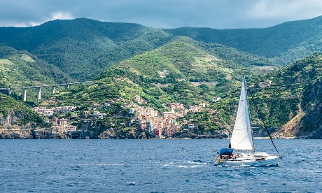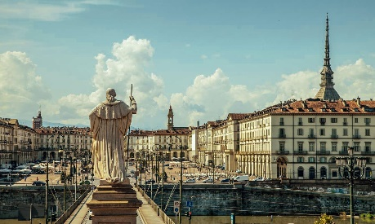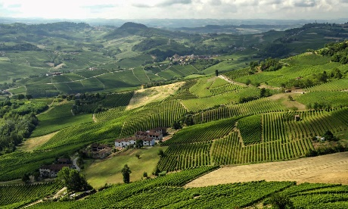
Cod. 009MIEN

DAY 1) MILAN – GENOA (140 km)
Departure at 08.30 am from Milan to Genoa (departure is also possible directly from Genoa joining the group at 10.45). Visit of this seaport, one of the largest of the Southern Europe, the first in Italy; 6th city of the country, this town has an important history, as a Maritime Republic. Its historical centre has grown around the dock, is full of narrow and characteristic streets and has a medieval origin. Continue to the modern zone of “Ancient Port”, restored for the 500 years of America discovery by Christopher Columbus. Here we find the Aquarius, the second biggest in Europe. Lunch at your own. Accommodation in hotel and evening for personal interests. Overnight at the hotel.

Day 2) GENOA – RAPALLO (30 km) - SANTA MARGHERITA (3 km) – PORTOFINO (5 km) – GENOA (40 km)

Breakfast at the hotel. Today you will be invited to taste focaccia, a typical local kind of bread in both versions, regular and with cheese. Departure to Rapallo, famous tourist centre. Visit of the old town where a long promenade ends with the beautiful castle of Dragut. Then, road to Santa Margherita, beautiful seaside city of Riviera di Levante (Eastern Riviera), located in the Tigullio Gulf. Lunch at your own. In the afternoon, visit of Portofino. Around a little square, you can have a nice view of a group of high, coloured and picturesque houses. In the small port, during the high season, you can see expensive yachts from every part of the world. Finally, return to Genoa with a panoramic road. Overnight at the hotel.

Day 3) GENOA – the eastern coast: PORTOVENERE (110 km) – CINQUE TERRE (10 km) – GENOA (90 km)

Breakfast at the hotel and departure to Portovenere, a fishermen village located at the end of La Spezia Gulf. Visit. Ferry to Cinque Terre (if the atmospheric conditions doesn’t permit the boarding, the visit will be with a panoramic itinerary by bus/minivan and train.) Heritage of the Unesco, these 5 fishermen villages, symbolize a group unique in the world for its beautiful landscape and the medieval style of their buildings. Visit of the little village of Vernazza and Monterosso, the biggest of the five villages, characterised by long beaches and narrow streets full of restaurants and handcraft shops. Lunch at your own. In the afternoon coming back to Genoa. Overnight at the hotel.

Day 4) GENOA – the western coast: varazze (40 km) and finalborgo (40 km) – serralunga di CREA (160 km) – TURIN (65 km)

Breakfast at the hotel and outgoing to the western coast of Liguria. Arrival to Varazze, a picturesque and little village of fishermen with its nice corners and small beaches. Visit. Later, departure to Finalborgo, a typical medieval village at the bottom of the mountains where the Alps meets the Apennines. Lunch at your own. Departure in the afternoon to Turin, capital of the region, crossing the North of Monferrato with short stop in Crea, where we will visit the local Monastery, a UNESCO World Heritage. Arrival to Turin, overnight at the hotel.

DAY 5) TURIN – SUPERGA (8 km) – ROYAL PALACE OF VENARIA (20 km) - TURIN (15 km)
Breakfast at the hotel. Full day dedicated to visit the town. Departure to to Superga, the second hill of the region. Here, visit at the Basilica, built at the beginning of the 1700 by command of the King of Sardinia, Victor Amadeus II as the dedication to the Virgin in order to celebrate the victory of the Piedmont Army versus France and Spain. Continue to the famous Savoy Route, including the Royal Palace, in Venaria, the greatest abode of the Royal Family. This imposing structure inspired the French architects during the project of renovation of the Palace of Versailles, near Paris. Built in the second half of the 1600 by command of the Savoy Duke Charles Emmanuel that gave it as a gift to his wife, the palace presents the main central building as well as the largest park of the region. Lunch at your own. In the afternoon, visit of Turin. First capital of the Kingdom of Italy, main centre of car factory FIAT, cultural and university centre, it is nowadays the fourth biggest town of the country for inhabitants and the third for industrial development. The visit of the downtown includes Piazza Castello, with Palazzo Madama, old Roman gate and the Royal Palace; the Mole Antonelliana, the major landmark of the city, built by the architect Alessandro Antonelli in 1873: it houses the Museo Nazionale del Cinema, the National Museum of Film; the Cathedral which hedges in the Shroud, a linen cloth bearing the image of a man who appears to have been physically traumatized in a manner consistent with crucifixion, Jesus, according to the catholic tradition; Piazza San Carlo, with its galleries in typical Piedmont style; walk through Via Roma and Garibaldi and free time to enjoy the everyday life of this amazing city. Overnight at the hotel.

DAY 6) TURIN – ASTI (55 km) - THE LANGHE (25 km) – TURIN (65 km)
Breakfast at the hotel. Today, in the Langhe you will be invited to taste a glass of an extraodinary local red wine: Barolo. Morover, you will discover products made with both white and black truffles. Departure to Asti. The city presents Roman and baroque style and tracks of the Middle Age and of the Renaissance. In the world, it is known due to its top-production of wines, of which the most important one is the Asti Spumante. Visit of the downtown: Santa Maria Assunta Cathedral, Piazza Roma with the monument to Italy, the Red Tower, of the Roman age, the baroque palaces and the Middle Age towers. Later, continue to Alba, town considered as the capital of the Langhe, district of hills and strong production of wines, known also as the regional leader in the ambit of buying and selling of truffles and chocolates (Ferrero, the multinational factory in the production of tea, chocolate, biscuits all over the world). Founded in the pre-Roman age, Alba had an important role in the Middle Age. Visit of the Cathedral, the old town centre with the road of business, Vittorio Emanuele and Cavour and the City Hall Palace. Lunch at your own. In the afternoon, through an amazing trip among hills and vineyards, arrive to Grinzane Cavour, that houses the castle with the same name and some of the main wine bars of the area. There, the first Italian Prime Minister, Camillo Cavour created the myth of the Barolo and La Morra, a small village of the Middle Age. It grounds its richness on the so called “Red gold”, the Barolo. Visit of the old town with great views towards the Langhe hills. Then, back to Turin. Overnight at the hotel.

DAY 7) TURIN – COURMAYEUR/MT. BLANC (140 km) - AOSTA (30 km) – MILAN (180 km)
Breakfast at the hotel. Departure to Fenis to look up to the castle, built in the XII century, located in the highest valley of the region. Built by command of the family Challant because of a reason of prestige, now it represents one of the most charming masterpieces of that age in all Northern Italy. Then, departure to Courmayeur, a small village located at the bottom of the Mont Blanc, the last Italian place before the frontier with France. Entered in the collective imaginary due to its 11 km long tunnel between Italy and France under the Mont Blanc, it presents a unique and wonderful landscape among the best and most fascinating peaks of the Western Alps. Free time in the beautiful old town. Continuation to Aosta, capital of the autonomous region of Aosta Valley, the smallest region of the country, located in the middle of the highest mountains of the Alps. Old town, founded before Christ and partially built by the Romans according to the typical style of a Roman camp (core and parallel streets). Still today Roman tracks are extremely evident: Arch of Augustus, the Praetorian gates, the old entrances of the city and the modern district with more recent buildings, as the Cathedral and Piazza Chanoux with the City Hall. Lunch at your own and then, way back to Milan. End of services.
- Tour starts and finishes at Starhotels Anderson, Piazza Luigi di Savoia 20, Milan. Please contact us for any further information concerning transfers or additional service.

RATES PER PERSON:

 | COMFORT |  | LUXURY
2026 ITALIAN RIVIERA AND PIEDMONT | DBL | SGL | DBL | SGL
2026 MAIN SEASON = 27/04 – 22/06 – 05/10 | € 2,990 | € 3,740 | € 3,140 | € 3,840

IN THE CITIES OF GENOA AND TURIN A CITY TAX FOR ACCOMMODATION IS NOW COMPULSORY. EVERY CLIENT MUST PAY IT CHECKING OUT.

RATES INCLUDE:
- Itinerary as above according to the hotel option choice
- Bus at disposal for the mentioned itinerary
- English speaking escort guide/driver up to 8 people (driver and guide with more than 8)
- Cruise by boat at the Cinque Terre (in case of bad conditions of weather, the excursion will be by bus/minivan and panoramic train)
- Focaccia and Focaccia with cheese tasting in Liguria
- Barolo special red wine tasting in Piedmont
- Truffle cream tasting in Piedmont
- Local guide in Genoa, Cinque Terre and Turin
- Audioguide dutring the cruise at the Cinque Terre
- Free Wi-Fi on board

RATES DO NOT INCLUDE:
Meals, drinks, entrances, porterage, city taxes, tickets, tips extras and whatever not specified in “RATES INCLUDE”.

DATES OF DEPARTURE:

27/04/2026
22/06/2026
05/10/2026

IMPORTANT NOTES:

Between November 1st and March 31st, the ferry service at Cinque Terre does not work. The itinerary will be by bus/minivan between La Spezia and Manarola (in place of Portovenere) and by train from Manarola to Monterosso via Vernazza.

During the season from April to October, the ferry services are always achieved when the weather conditions permit them. In case this condition cannot be respected, the same activity will be replaced with the winter alternative as specified above.

HOTELS ACCOMMODATION OR SIMILAR – COMFORT TOUR:

GENOA: Hotel Best Western City Plus****, Via di San Sebastiano 6, Tel. +39/010 584707, https://www.hotelcitygenova.it/
TURIN: STARHOTEL MAJESTIC****, C.so Vittorio Emanuele II 54, Tel. +39/011 539153, http://www.starhotels./hotels/Majestic/it/home.aspx

HOTELS ACCOMMODATION OR SIMILAR – LUXURY TOUR:

GENOA: Hotel Best Western City Plus****, deluxe room, Via di San Sebastiano 6, Tel. +39/010 584707, https://www.hotelcitygenova.it/
TURIN: GRAND HOTEL SITEA*****, CLASSIC ROOM - Via Carlo Alberto 35, Tel. +39/517 0171, http://grandhotelsitea.it/

CANCELLATION POLICY:
- 100% no-show
- 70% from 1 to 3 days before the departure
- 50% from 3 to 14 days before the departure
- 30% from 14 to 21 days before the departure

