SARDINIA TOUR
From OLBIA
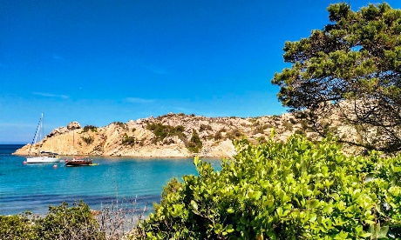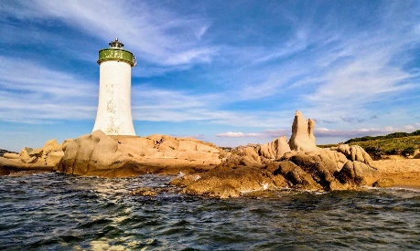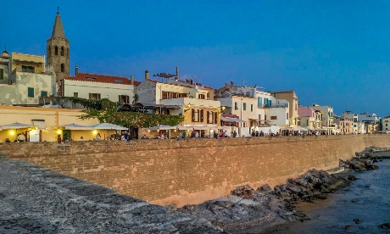
Cod. 010OLEN

DAY 1) OLBIA – ORISTANO (170 km) – CAGLIARI (90 km)
At 09:00, departure from the center of Olbia to the south of the second largest island in the Mediterranean, Sardinia. On the way, stop in Oristano, former capital of the Court of Arborea, one of the four medieval regions that made up the island. Today it is the largest internal city in the center-west, a fundamental connection hub between the largest ports in Sardinia. Arrival in Cagliari and in the afternoon, visit of the city, capital, largest commercial and cultural center of the island. Check in and accommodation.

DAY 2) CAGLIARI – BOSA (190 km) – ALGHERO (50 km)
Breakfast at the hotel. Departure for the north of Sardinia with a stop at the ancient Phoenician, Byzantine and finally Genoese city of Bosa, located on the Temo river, around which the medieval center developed. For centuries it was the reference point of leather working on the island and today it is an important tourist center on the western coast of Sardinia. Arrival in Alghero, a very charming town that rises on a top of a small promontory that overlooks the waters of the homonymous bay, with wide beaches around it. Visit of the historic center between the walls. Rest of the day on your own in the center of the capital of th coral. Hotel accommodation.

DAY 3) ALGHERO – CAPO CACCIA (25 km) – STINTINO (50 km) - CASTELSARDO (60 km) – PALAU (80 km)
Breakfast at the hotel. Departure to Capo Caccia, the extreme western tip of the wonderful bay of Porto Conte with a stop at a panoramic point to admire the bay with its beautiful caves. Next, continue to Stintino, a place with beautiful beaches, in front of the Asinara Island. Here a small fishing village alternates with luxury hotels and resorts. Possibility to relax on one of the white and uncontaminated beaches. Lunch on your own. In the afternoon, departure to Castelsardo. Old and wonderful town, with its medieval town of Genoese origin. Its coastline, local crafts and tourist structures make it the ideal place for summer holidays. Finally arrival in Palau, check in and accommodation.

DAY 4 ) PALAU – EMERALDA COAST (60 km) – PALAU (40 km)
Breakfast at the hotel. Excursion along the Emerald Coast. The territory of Arzachena is part of the very famous Emerald Coast, a rich portion of nature, Mediterranean maquis, rocks shaped by nature, magnificent beaches with a clear and unpolluted sea, headlands and small islands. The Emerald Coast was born in 1962 by a group of international financiers led by the Ismaili prince Karin Aga Khan IV. Stops in the towns of Poltu Quatu, Porto Cervo and Porto Rotondo. Free time to enjoy one of the most famous beaches on the Coast. Lunch on your own. Return to Palau. Hotel accommodation.

DAY 5) PALAU – ISLANDS MADDALENA AND CAPRERA (20 km) – SANTA TERESA DI GALLURA (25 KM) – OLBIA (60 km)
Breakfast at hotel. Depart by ferry to the Maddalena and Caprera Islands. The tourist offer of this archipelago is not only beaches, sea and fun. This area has been characterized by many events and visited by illustrious historical figures who have even lived here. The most famous was Giuseppe Garibaldi to whom they dedicated a Museum on the Island of Caprera. After the visit, departure to Santa Teresa di Gallura, which conquered a privileged place in the collective imagination of travelers, for evoking at the same time the ductile and the strong of nature; It represents one of the cultural places of the Mediterranean. The promontory, like a cathedral, imposing, severe, of enormous suggestion, stands in front of the white rocks of Corsica and precipitates with its enormous rocks of inconsistent and very evocative shapes in one of the most suggestive marine areas in the world, that is, the Strait of Bonifacio. Lunch on your own. Next, transfer back to Olbia and end of services.
- Tour starts and finishes at Hotel Mercure Olbia, Via Puglie. Please contact us for any further information concerning transfers or additional service.

RATES PER PERSON:

 | COMFORT |  | LUXURY
2026 SARDINIA TOUR | DBL | SGL | DBL | SGL
2026 MAIN SEASON = 04/05 – 01/06 – 07/09 – 28/09 | € 2,450 | € 2,810 | € 2,710 | € 3,290

IN THE TOWNS OF PALAU AND ALGHERO A CITY TAX FOR ACCOMMODATION IS NOW COMPULSORY. EVERY CLIENT MUST PAY IT CHECKING OUT.

RATES INCLUDE:
- Itinerary as above according to the hotel option choice
- Bus at disposal for the mentioned itinerary
- English speaking escort guide/driver up to 8 people (driver and guide with more than 8)
- Local guide in Cagliari
- Ferry to La Maddalena and Caprera from Palau
- Typical Sardinian cake tasting
- Myrtle liqueur tasting
- Free Wi-Fi on board

RATES DO NOT INCLUDE:
Meals, drinks, entrances, porterage, city taxes, tickets, tips extras and whatever not specified in “RATES INCLUDE”.

DATES OF DEPARTURE:

04/05/2026
01/06/2026
07/09/2026
28/09/2026

HOTELS ACCOMMODATION OR SIMILAR – COMFORT TOUR:
CAGLIARI: HOTEL REGINA MARGHERITA****​, Viale Regina Margherita 44, https://www.hotelreginamargherita.com/

ALGHERO: HOTEL CATALUNYA****, Via Catalogna 24, tel. +39/079 953172, http://www.hotelcatalunya.it/

PALAU: HOTEL LA VECCHIA FONTE****S, Via Fonte Vecchia 48, Tel. +39/0789 709750, http://www.hotelpalau.it/

HOTELS ACCOMMODATION OR SIMILAR – LUXURY TOUR:
​ ​CAGLIARI: HOTEL PALAZZO DOGLIO*****, Vico Logudoro 1, https://www.palazzodoglio.com/
ALGHERO: HOTEL CARLOS V***** SEAVIEW ROOM, Lungomare Valencia 24, Tel. +39/079 9720600, http://www.hotelcarlosv.it/

PALAU: Hotel LA VECCHIA FONTE^{****S} SUPERIOR ROOM, Via Fonte Vecchia 48, Tel. +39/0789 709750, http://www.hotelpalau.it/

CANCELLATION POLICY:
- 100% no-show
- 70% from 1 to 3 days before the departure
- 50% from 3 to 14 days before the departure
- 30% from 14 to 21 days before the departure

