MEDIEVAL TUSCANY TOUR
from ROME
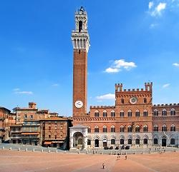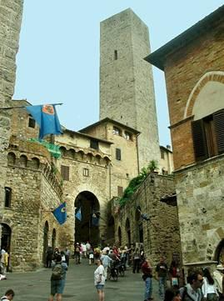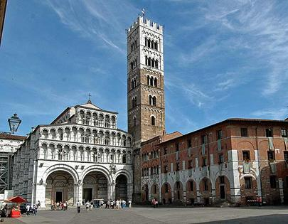
cod. 012RMEN

DAY 1) ROME – TIVOLI (35 km) - ORVIETO (130 km) – SIENA (125 km)
Departure at 08.30 am from Rome to Tivoli, beautiful village in the surroundings of Rome, famous for its villas, UNESCO World Heritage. Visit of the old town to admire medieval buildings, ancient Roman runis and the amazing view at river Aniene. Later, departure to Orvieto. The Gothic Cathedral, majestic and elaborate, shines on the top of a sinuous hill with its facade but the city of the St. Patrick Well, commissioned by Pope Clement VII offers many nice corners to feel the medieval atmosphere of the city, try the excellent wines or the renowned food. Visit. Lunch at your own. In the afternoon, departure to Siena. Overnight at the hotel.
DAY 2) SIENA – SAN GIMIGNANO (45 km) – VOLTERRA (30 km) - SIENA (55 km)
Breakfast. In the morning, visit of the city of Siena. Surrounded by the vineyards of Chianti on one side, and coloured fields on the other, the city seems to extend over a low hill, in a central position with respect to the lands that have always been its domain. The famous city of Palio and the contrade fascinates by the thousands of colours of its flags, its twisted streets, the perfection of its gothic monuments, the fame of its illustrious citizen and the taste of the products that can be tasted here. Departure to San Gimignano, the city of the towers, where we will visit Porta San Giovanni, Piazza della Cisterna, Palazzo del Popolo, the Civic Museum and the Church of Saint Augustine. Lunch at your own. Continuation to Volterra. Located on the highest point of a high hill, the city with its austere and medieval silhouette is famous for its alabaster craftsmanship. Visit of the city with the Piazza and Palazzo dei Priori Palace, the Duomo, the Baptistery, Porta dell’Arco, Etruscan gate that dates back the 4th century BC and the theatre that dates back the Roman age. Return to Siena and overnight at the hotel.
DAY 3) SIENA – CHIANTI ROUTE (50 km) – LUCCA (100 km) – SIENA (140 km)
Breakfast. Today you will be invited to taste the most popular Italian wine in the world: Chianti, red wine produced with Sangiovese Tuscany grapes. In the morning, take the Strada del Chianti – Chianti Route. Along the way, we can see the charming hills, the picturesque villages with their ancient towers, the farms and of course the vineyards. Visit of Radda in Chianti, the old town and its walls. Then visit of Greve in Chianti with its asymmetrical square with porticos and terraces. Departure towards Lucca, a city surrounded by a Reinassence wall that has been preserved perfectly and is still walkable on the top. Lunch at your own. In the afternoon, visit of Napoleon Square, the Palace of the Province, the Duomo, the Church of San Michele in Foro and the house where the great composer Giacomo Puccini was born. Then, back to Siena and overnight at the hotel.
DAY 4 ) SIENA – MONTALCINO (40 km) - PIENZA (20 km) – MONTEPULCIANO (15 km) – ROME (170 km)
Breakfast. Today, we will visit an antique wine cellar, built in a 15th century building with the opportunity to taste the excellent red Vino Nobile di Montepulciano. Departure to Montalcino; the great fortress characterizes the city, which looms over the three valleys of Asso, d'Aria and Orcia. Visit. Continue to Pienza. This city, on top of a hill overlooking the Orcia Valley, is an essential stage for its artistic beauties and the good gastronomy typical of the place. The famous Piazza Pio II overlooks the Cathedral, the Piccolomini Palace, the Palazzo Comunale, Borgia Palace are the symbol of the Renaissance style introduced there by the architect Rossellino in the 1400s. The wonderful panoramic promenade along the walls allows us to see the entire valley closed at the bottom of Mount Amiata. Departure towards Montepulciano. The town, an art pearl of 1500s, is located 750 meters above sea level on top of a hill near the Val di Chiana, in a territory already inhabited in the Etruscan and Roman age. Its fame is owed mainly by the production of the wine Nobile, red of great quality. Visit. Lunch at your own. Return to Rome. End of services.
- Tour starts and finishes at Starhotels Metropole, Via Principe Amedeo 3, Rome. Please contact us for any further information concerning transfers or additional service.

RATES PER PERSON:
 | COMFORT |  | LUXURY
2026 TUSCANY | DBL | SGL | DBL | SGL
2026 SHOULDER SEASON = 12/02 - 12/03 – 23/07 – 20/08 – 26/11 | € 1,360 | € 1,650 | € 1,440 | € 1,760
2026 HIGH SEASON = 02/04 – 14/05 – 18/06 – 24/09 – 22/10 | € 1,480 | € 1,860 | € 1,570 | € 2,140

IN THE TOWN OF SIENA A CITY TAX FOR ACCOMMODATION IS NOW COMPULSORY. EVERY CLIENT MUST PAY IT CHECKING OUT.

RATES INCLUDE:
- Itinerary as above according to the hotel option choice
- Private minivan or coach
- English speaking escort guide/driver up to 8 people (driver and guide with more than 8)
- Nobile di Montepulciano and Chianti red wine tasting
- Local guide in Siena
- Wi-fi on board

RATES DO NOT INCLUDE
Meals, drinks, entrances, porterage, city taxes, tickets, tips extras and whatever not specified in “RATES INCLUDE”.

DATES OF DEPARTURE:

12/03/2026
12/03/2026
02/04/2026
14/05/2026
18/06/2026
23/07/2026
20/08/2026
24/09/2026
22/10/2026
26/11/2026

NOTE:
During the season from November to March, departures will be guaranteed with a minimum of 4 pax.

HOTELS ACCOMMODATION OR SIMILAR – COMFORT TOUR:

SIENA: NH Siena, Giardini La Lizza 1, tel. +39/0577 382111, https://www.nh-hotels.com/it/hotel/nh-siena

HOTELS ACCOMMODATION OR SIMILAR – LUXURY TOUR:

SIENA: Hotel Athena****, Via Mascagni 55, tel. +39/0577 286313, http://www.hotelathena.com/
SUPERIOR ROOM

CANCELLATION POLICY:
- 100% no-show
- 70% from 1 to 3 days before the departure
- 50% from 3 to 14 days before the departure
- 30% from 14 to 21 days before the departure

