APULIA TOUR
from ROME

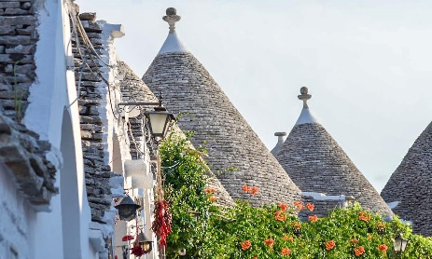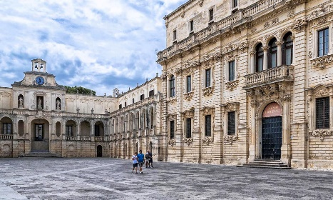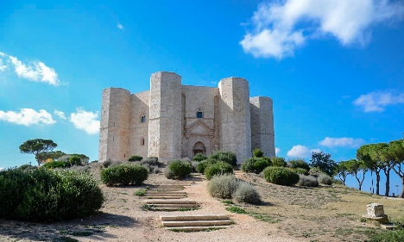
cod. 013BAEN
DAY 1) BARI
Arrival to the hotel on your own. Check in and accommodation.
DAY 2) BARI – TRANI (50 km) - BARI
Breakfast. At 09:00, meeting with local guide and guided tour of Bari, capital of the Apulia region. Panoramic tour between the Norman-Swabian castle, the port, the Margherita and Petruzzelli theaters. Walk through the streets of Bari Vecchia, the ancient city that stands out for the old medieval walls, the Basilica of Saint Nicholas and the narrow streets where you can admire the housewives trying to produce orecchiette, fresh homemade pasta typical of the region . Next, continue to Trani, a beautiful maritime city, famous for its beautiful Cathedral overlooking the Adriatic and the port area, rich in restaurants and craft shops and typical products. Return to Bari and accommodation.
DAY 3) BARI – POLIGNANO A MARE (35 km) – OSTUNI (50 km) - LECCE (80 km)
Breakfast. Departure for Polignano a Mare, the city famous for being the birthplace of the most famous Italian singer of all time, Domenico Modugno. This charming city will surprise with its old town, perched on the walls that frame a splendid beach. Continuation to Ostuni, the city of white houses, a beautiful tourist center that stands out for the Cathedral, a masterpiece in a mixture of Romanesque, Gothic and Baroque. Walk through the picturesque streets of the historic center and lunch on your own. Later, continuation to Lecce, check in and accommodation.
DAY 4) LECCE – GALLIPOLI (40 km) – OTRANTO (40 km) – LECCE (45 km)
Breakfast. In the morning, guided tour of Lecce and time dedicated to discover this city, already defined as the Baroque capital of southern Italy; a cultural and historical center of almost 100,000 inhabitants that hides in its ancient case buildings of rare beauty, built over the centuries with the said stone of Lecce: the Cathedral, the Basilica of the Holy Cross, the Celestini Palace, the Roman Theater, le elegant and central Plaza de San Oronzo with the characteristic column and entrance doors of the ancient city. Next, departure for Gallipoli, Gallipoli, an old fishing village located on an island that in the 17th century was joined to the mainland with a bridge, still busy today. Visit of the beautiful and picturesque historic center. Lunch on your own. Next, arrival in Otranto, the easternmost municipality of the entire Italian peninsula and a great Norman center in ancient times. A walled city, it grew around the castle and the Cathedral and today is an important tourist center due to its location on the Adriatic, its beaches and the elegant Promenade of Heroes. Visit and then return to Lecce and hotel accommodation.

DAY 5 LECCE – ALBEROBELLO (120 km) – MATERA (70 km)
Breakfast. Departure to one of the most picturesque places known in the world for its characteristic homes: Alberobello. In the 17th century, the peasants of the area, to avoid paying taxes to the Kingdom of Naples on their houses, began to build with dry stone, which according to the law of the time could not be considered a true place to live. The low local buildings with black roofs have survived to this day and many have been converted into luxury homes, craft shops or hotels. Lunch on your own. Next, departure for the Basilicata region, bound for Matera. The city of the “Sassi” is also a UNESCO World Heritage Site for its old quarter, which is an example of prehistoric urbanization. Today the ancient caves have been reused for daily and tourist life and make up a truly unique landscape that is worth experiencing. Visit and hotel accommodation.
Day 6 MATERA - BARI (60 km)
Breakfast. After a last morning on your own in Matera, at 11 am transfer of the passengers to Bari and end of services.
- Tour starts and finishes at Hotel Excelsior, Via Petroni 15, Bari. Please contact us for any further information concerning transfers or additional service.

RATES PER PERSON:
 | COMFORT |  | LUXURY
2026 APULIA | DBL | SGL | DBL | SGL
2026 HIGH SEASON = 22/02 – 12/04 – 17/05 – 07/06 – 13/09 – 11/10 - 08/11 | € 2,135 | € 2,530 | € 2,990 | € 4,120
2026 TOP SEASON = 05/07 – 23/08 | € 2,190 | € 2,650 | € 3,040 | € 4,150

IN THE TOWNS OF BARI, LECCE AND MATERA A CITY TAX FOR ACCOMMODATION IS NOW COMPULSORY. EVERY CLIENT MUST PAY IT CHECKING OUT.
RATES INCLUDE:
- Itinerary as above according to the hotel option choice
- Private minivan or coach
- English speaking escort guide/driver up to 8 people (driver and guide with more than 8)
- Focaccia barese tasting (with drink included) in Bari
- Entrance to an underground ancient oil producer in Gallipoli
- Wi-fi on board

RATES DO NOT INCLUDE
Meals, drinks, entrances, porterage, city taxes, tickets, tips extras and whatever not specified in “RATES INCLUDE”.

DATES OF DEPARTURE:

22/02/2026 – Low Season
12/04/2026
17/05/2026
07/06/2026
05/07/2026
23/08/2026
13/09/2026
11/10/2026
08/11/2026 – Low Season

NOTE:
During the season from November to March, departures will be guaranteed with a minimum of 4 pax.

HOTELS ACCOMMODATION OR SIMILAR – COMFORT TOUR:
Bari: Hotel Excelsior****, Via Petroni 15, tel. +39/080 5564366, https://excelsiorbari.it/
Lecce: Hotel delle Palme****, Via di Leuca, 90, Lecce, tel. +39/ 0832 347171, https://www.hoteldellepalmelecce.it/ or Grand Hotel Lecce****, Viale Quarta 28, Lecce, tel. +39/ 0832 309405
Matera: Hotel San Domenico****, Via Roma 15, tel. +39/0835 256309, http://www.hotelsandomenico.it/

HOTELS ACCOMMODATION OR SIMILAR – LUXURY TOUR:
Bari: Grand Hotel delle Nazioni*****, Lungomare Nazario Sauro 7/9, tel. +39/080 5920111, http://www.grandealbergodellenazioni.com/
Lecce: Patria Palace Hotel*****, Piazzetta Riccardi 13, tel. +39/0832 245111, https://patriapalace.com/
Matera: Eurostars La Suite Matera Hotel & Spa*****, Via Lucania 137, tel. +39/0835 1970204, https://www.eurostarshotels.it/eurostars-matera-la-suite.html

CANCELLATION POLICY:

- 100% no-show
- 70% from 1 to 3 daysbefore the departure
- 50% from 3 to 14 daysbefore the departure
- 30% from 14 to 21 daysbefore the departure

