The Beautiful Costiera:
Sorrento, Capri, Amalfi Coast, Pompeii and Naples
from SALERNO

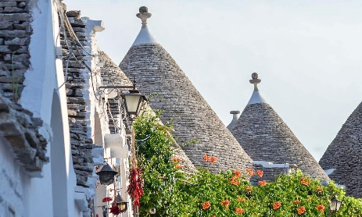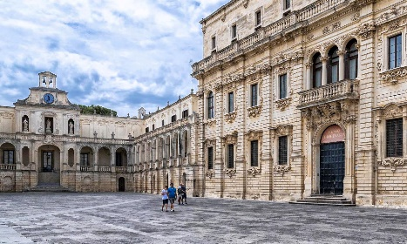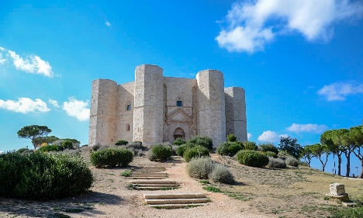
cod. 016SAEN
DAY 1) SALERNO – SORRENTO
Private transfer from the centre of Salerno (or Naples) to your hotel in Sorrento, the major city of the gulf with the same name. Check-in and accommodation.
DAY 2) SORRENTO – CAPRI – SORRENTO
Breakfast. Daily excursion to the Capri with in/out transfers from the hotel to the port (when necessary, depending of the position of the hotel); meeting with local guide and departure by fast ferry to one of the most popular and beloved islands of the Mediterranean. Tour by minibus trhough the villages of Anacapri and Capri. Lunch on your own. Enjoy the Piazzetta and the amazing spots of the islands. Return to Sorrento by ferry and accommodation.
DAY 3) SORRENTO – POSITANO – AMALFI – SORRENTO
Breakfast. Daily excursion to the Amalfi Coast with in/out transfers from the hotel to the port (when necessary, depending of the position of the hotel); meeting with local guide and departure by ferry to Positano, the most charming village of the coast, famous for its coloured spots that perfectly mixes tradition and luxury. Continuartion to Amalfi, visit of the old town and the Cathedral. You will have the chance to enjoy your time walking in the narrow streets of this amazing village. Return ny boat to Sorrento and accommodation.
DAY 4) SORRENTO – POMPEII – NAPOLES – SORRENTO
Breakfast. Depature to Pompeii, a unique archaeological park to discover the urban life of the local population until the eruptiomn of the volcano Vesuvio in 79 D.C. Lunch on your own. Continuation to Naples for a panoramic and a walking tour in the old town. Return to Sorrento and accommodation.

DAY 5) SORRENTO - NAPOLES
Breakfast. Private transfer to the hotel or train station or airport in Naples downtown. END OF SERVICES.

- Tour starts in the centre of Salerno or Naples (hotel, train station or port) and finishes in Naples (airport, train station or hotel). Please contact us for any further information concerning transfers or additional service.

RATES PER PERSON:
 | COMFORT |  | LUXURY
2026 BEAUTIFUL COSTIERA | DBL | SGL | DBL | SGL
2026 HIGH SEASON = 19/04 – 24/05 – 14/06 – 18/10 | € 2,720 | € 3,380 | € 2,820 | € 4,660
2026 TOP SEASON = 12/07 – 30/08 – 20/09 | € 2,860 | € 3,520 | € 2,910 | € 4,890

IN THE TOWN OF SORRENTO A CITY TAX FOR ACCOMMODATION IS NOW COMPULSORY. EVERY CLIENT MUST PAY IT CHECKING OUT.
RATES INCLUDE:
- Itinerary as above according to the hotel option choice;
- In/out private transfers;
- English speaking assistant at the check in in Sorrento;
- Local guide for services on day 2, 3 and 4;
- Minibuses for transfers hotel to port and return in Sorrento (when necessary; depends on the location of the hotel) and for the visit of the island of Capri;
- Ferry Sorrento – Positano – Amalfi - Sorrento
- Fast Ferry Sorrento – Capri return ticket;

RATES DO NOT INCLUDE
Meals, drinks, entrances, porterage, city taxes, tickets, tips extras and whatever not specified in “RATES INCLUDE”.

DATES OF DEPARTURE:
19/04/2026
24/05/2026
14/06/2026
12/07/2026
30/08/2026
20/09/2026
18/10/2026

HOTELS ACCOMMODATION OR SIMILAR – COMFORT TOUR:

SORRENTO: Hotel Meridiana*** sup., Via Bernardino Rota 1, Sorrento (NA), Tel. +39/081 8073535, https://www.lameridianasorrento.com/

HOTELS ACCOMMODATION OR SIMILAR – LUXURY TOUR:

META: Hotel Giosuè a Mare****, Via Caruso 2, Meta di Sorrento (NA), Tel. +39/081 8786685, https://www.giosueamare.it/en/

CANCELLATION POLICY:

- 100% no-show
- 70% from 1 to 3 daysbefore the departure
- 50% from 3 to 14 daysbefore the departure
- 30% from 14 to 21 daysbefore the departure

