The GRAND TOUR OF APULIA, CALABRIA AND THE Beautiful Costiera:
Sorrento, Capri, Amalfi Coast, Pompeii and Naples
from BARI

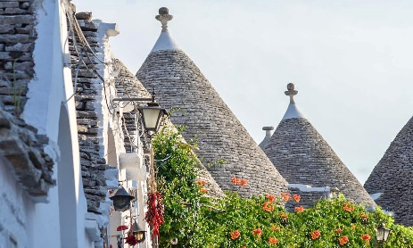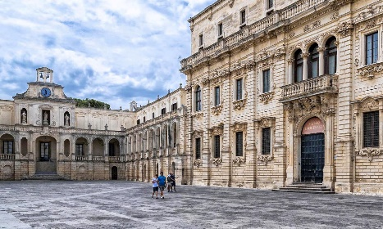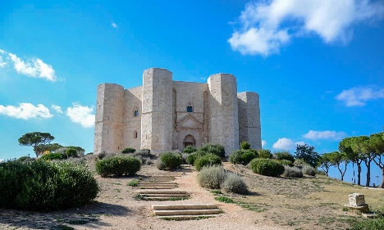
cod. 017BAEN
DAY 1) BARI
Arrival to the hotel on your own. Check in and accommodation.
DAY 2) BARI – TRANI (50 km) - BARI
Breakfast. At 09:00, meeting with local guide and guided tour of Bari, capital of the Apulia region. Panoramic tour between the Norman-Swabian castle, the port, the Margherita and Petruzzelli theaters. Walk through the streets of Bari Vecchia, the ancient city that stands out for the old medieval walls, the Basilica of Saint Nicholas and the narrow streets where you can admire the housewives trying to produce orecchiette, fresh homemade pasta typical of the region . Next, continue to Trani, a beautiful maritime city, famous for its beautiful Cathedral overlooking the Adriatic and the port area, rich in restaurants and craft shops and typical products. Return to Bari and accommodation.
DAY 3) BARI – POLIGNANO A MARE (35 km) – OSTUNI (50 km) - LECCE (80 km)
Breakfast. Departure for Polignano a Mare, the city famous for being the birthplace of the most famous Italian singer of all time, Domenico Modugno. This charming city will surprise with its old town, perched on the walls that frame a splendid beach. Continuation to Ostuni, the city of white houses, a beautiful tourist center that stands out for the Cathedral, a masterpiece in a mixture of Romanesque, Gothic and Baroque. Walk through the picturesque streets of the historic center and lunch on your own. Later on, continuation to Lecce, check in and accommodation.
DAY 4) LECCE – GALLIPOLI (40 km) – OTRANTO (40 km) – LECCE (45 km)
Breakfast. In the morning, guided tour of Lecce and time dedicated to discover this city, already defined as the Baroque capital of southern Italy; a cultural and historical center of almost 100,000 inhabitants that hides in its ancient case buildings of rare beauty, built over the centuries with the said stone of Lecce: the Cathedral, the Basilica of the Holy Cross, the Celestini Palace, the Roman Theater, le elegant and central Plaza de San Oronzo with the characteristic column and entrance doors of the ancient city. Next, departure for Gallipoli, Gallipoli, an old fishing village located on an island that in the 17th century was joined to the mainland with a bridge, still busy today. Visit of the beautiful and picturesque historic center. Lunch on your own. Next, arrival in Otranto, the easternmost municipality of the entire Italian peninsula and a great Norman center in ancient times. A walled city, it grew around the castle and the Cathedral and today is an important tourist center due to its location on the Adriatic, its beaches and the elegant Promenade of Heroes. Visit and then return to Lecce and hotel accommodation.

DAY 5) LECCE – ALBEROBELLO (120 km) – MATERA (70 km)
Breakfast. Departure to one of the most picturesque places known in the world for its characteristic homes: Alberobello. In the 17th century, the peasants of the area, to avoid paying taxes to the Kingdom of Naples on their houses, began to build with dry stone, which according to the law of the time could not be considered a true place to live. The low local buildings with black roofs have survived to this day and many have been converted into luxury homes, craft shops or hotels. Lunch on your own. Next, departure for the Basilicata region, bound for Matera. The city of the “Sassi” is also a UNESCO World Heritage Site for its old quarter, which is an example of prehistoric urbanization. Today the ancient caves have been reused for daily and tourist life and make up a truly unique landscape that is worth experiencing. Visit and hotel accommodation.
DAY 6) MATERA – CIVITA (140 km) – ALTOMONTE (40 km) – COSENZA (60 km)
Breakfast at the hotel. Departure to Civita and visit the "village between the rocks", an interesting medieval village, guardian of the culture and traditions of the Albanian communities (Arbëreshë) in Italy. Continuation towards Altomonte, a town on the heights of the Province of Cosenza that stands out for its Norman Tower, Piazza San Francesco, the heart of the village and the Church of Santa Maria della Consolazione. Later, departure for Cosenza, visit of the old town, check in and accommodation.

DAY 7) COSENZA – TROPEA (120 km) – PIZZO (30 km) - COSENZA (90 km)
Breakfast at the hotel. Departure for Tropea, a famous tourist center that fascinates visitors with its picturesque alleys and terraces more than fifty meters above the crystalline sea. Visit and lunch on your own. Next, continue to Pizzo, the centre of the famous Coast of the Gods, known as the "City of Ice Cream", where there will be time to visit the town and enjoy the inevitable "Tartufo", typical ice cream of the area. Return to Cosenza and accommodation.
DAY 8) COSENZA – PAOLA (35 km) – SAN NICOLA ARCELLA (65 km) – SALERNO (170 km) - SORRENTO
Breakfast at the hotel. Departure to Paola and visit of the Sanctuary of San Francesco di Paola, originally built om the 16th century, on a hill surrounded by vegetation that houses the relics of the patron saint of Calabria. Continuation through Praia a Mare to admire the beautiful bay with the island of Dino, the largest of the Calabrian islands in the Tyrrhenian Sea, with its splendid caves full of stalagmites until reaching the highest point of the promontory, the town of San Nicola Arcella, with its natural viewpoint. Lunch on your own and then transfer to Sorrento via Salerno. Check in and accommodation.

DAY 9) SORRENTO – CAPRI – SORRENTO
Breakfast. Daily excursion to the Capri with in/out transfers from the hotel to the port (when necessary, depending on the position of the hotel); meeting with local guide and departure by fast ferry to one of the most popular and beloved islands of the Mediterranean. Tour by minibus through the villages of Anacapri and Capri. Lunch on your own. Enjoy the Piazzetta and the amazing spots of the islands. Return to Sorrento by ferry and accommodation.
DAY 10) SORRENTO – POSITANO – AMALFI – SORRENTO
Breakfast. Daily excursion to the Amalfi Coast with in/out transfers from the hotel to the port (when necessary, depending of the position of the hotel); meeting with local guide and departure by ferry to Positano, the most charming village of the coast, famous for its coloured spots that perfectly mixes tradition and luxury. Continuartion to Amalfi, visit of the old town and the Cathedral. You will have the chance to enjoy your time walking in the narrow streets of this amazing village. Return ny boat to Sorrento and accommodation.
DAY 11) SORRENTO – POMPEI – NAPOLES – SORRENTO
Breakfast. Depature to Pompeii, a unique archaeological park to discover the urban life of the local population until the eruptiomn of the volcano Vesuvio in 79 D.C. Lunch on your own. Continuation to Naples for a panoramic and a walking tour in the old town. Return to Sorrento and accommodation.
DAY 12) SORRENTO - NAPOLES
Breakfast. Private transfer to the hotel or train station or airport in Naples downtown. END OF SERVICES.

- Tour starts at Hotel Excelsior, Via Petroni 15, Bari and finishes in Naples (airport, train station or hotel). Please contact us for any further information concerning transfers or additional service.

RATES PER PERSON:
 | COMFORT |  | LUXURY
2026 GRAND TOUR OF APULIA, CALABRIA AND THE BEAUTIFUL COSTIERA | DBL | SGL | DBL | SGL
2026 HIGH SEASON = 12/04 – 17/05 – 07/06 – 11/10 | € 5,520 | € 6,640 | € 6,480 | € 8,370
2026 TOP SEASON = 05/07 – 23/08 – 13/09 | € 5,690 | € 6,820 | € 6,610 | € 8,640

IN THE TOWN OF SORRENTO A CITY TAX FOR ACCOMMODATION IS NOW COMPULSORY. EVERY CLIENT MUST PAY IT CHECKING OUT.
RATES INCLUDE:
- Itinerary as above according to the hotel option choice
- Private minivan or coach from day 1 to day 8;
- English speaking escort guide/driver up to 8 people (driver and guide with more than 8) from day 1 to day 8;
- Focaccia barese tasting (with drink included) in Bari
- Entrance to an underground ancient oil producer in Gallipoli;
- All transfers from day 9 to 12;
- English speaking assistant at the check in in Sorrento;
- Local guide for services on day 9, 10 and 11;
- Minibuses for transfers hotel to port and return in Sorrento (when necessary; depends on the location of the hotel) and for the visit of the island of Capri;
- Ferry Sorrento – Positano – Amalfi - Sorrento
- Fast Ferry Sorrento – Capri return ticket;
- Wi-fi on board from day 1 to 8;

RATES DO NOT INCLUDE
Meals, drinks, entrances, porterage, city taxes, tickets, tips extras and whatever not specified in “RATES INCLUDE”.

DATES OF DEPARTURE:
12/04/2026
17/05/2026
07/06/2026
05/07/2026
23/08/2026
13/09/2026
11/10/2026

HOTELS ACCOMMODATION OR SIMILAR – COMFORT TOUR:

Bari: Hotel Excelsior****, Via Petroni 15, tel. +39/080 5564366, https://excelsiorbari.it/
Lecce: Hotel delle Palme****, Via di Leuca, 90, Lecce, tel. +39/ 0832 347171, https://www.hoteldellepalmelecce.it/ or Grand Hotel Lecce****, Viale Quarta 28, Lecce, tel. +39/ 0832 309405
Matera: Hotel San Domenico****, Via Roma 15, tel. +39/0835 256309, http://www.hotelsandomenico.it/
Cosenza: Hotel Royal****, Viale delle Medaglie d’Oro 1, tel. +39/0984 412165, https://www.hotelroyalcosenza.it/
Sorrento: Hotel Meridiana*** sup., Via Bernardino Rota 1, Sorrento (NA), Tel. +39/081 8073535, https://www.lameridianasorrento.com/

HOTELS ACCOMMODATION OR SIMILAR – LUXURY TOUR:

Bari: Grand Hotel delle Nazioni*****, Lungomare Nazario Sauro 7/9, tel. +39/080 5920111, http://www.grandealbergodellenazioni.com/
Lecce: Patria Palace Hotel*****, Piazzetta Riccardi 13, tel. +39/0832 245111, https://patriapalace.com/
Matera: Eurostars La Suite Matera Hotel & Spa*****, Via Lucania 137, tel. +39/0835 1970204, https://www.eurostarshotels.it/eurostars-matera-la-suite.html
Cosenza: Hotel Royal****, junior suite, Viale delle Medaglie d’Oro 1, tel. +39/0984 412165, https://www.hotelroyalcosenza.it/

META: Hotel Giosuè a Mare****, Via Caruso 2, Meta di Sorrento (NA), Tel. +39/081 8786685, https://www.giosueamare.it/en/

CANCELLATION POLICY:

- 100% no-show
- 70% from 1 to 3 daysbefore the departure
- 50% from 3 to 14 daysbefore the departure
- 30% from 14 to 21 daysbefore the departure

