TOUR OF CALABRIA AND THE Beautiful Costiera:
Sorrento, Capri, Amalfi Coast, Pompeii and Naples
from BARI

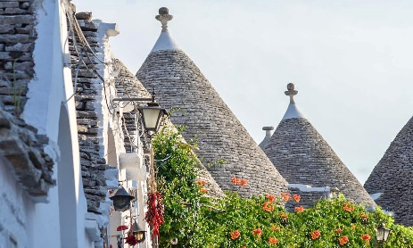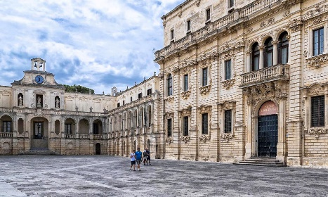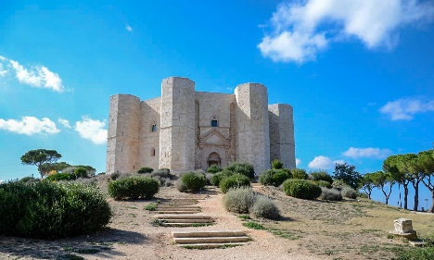
cod. 018BAEN
DAY 1) BARI - MATERA (70 km)
Departure from the centre of Bari to reach Matera: the "City of the Sassi" is known for the historic Sassi districts, recognized World Heritage Site by UNESCO in 1993. The area, populated since the prehistory makes Matera as one of the oldest settlements in the world. Check in, lunch at your own and in the afternoon visit of the old town on foot. Accommodation and overnight at the hotel.
DAY 2) MATERA – CIVITA (140 km) – ALTOMONTE (40 km) – COSENZA (60 km)
Breakfast at the hotel. Departure to Civita and visit the "village between the rocks", an interesting medieval village, guardian of the culture and traditions of the Albanian communities (Arbëreshë) in Italy. Continuation towards Altomonte, a town on the heights of the Province of Cosenza that stands out for its Norman Tower, Piazza San Francesco, the heart of the village and the Church of Santa Maria della Consolazione. Later, departure for Cosenza, visit of the old town, check in and accommodation.

DAY 3) COSENZA – TROPEA (120 km) – PIZZO (30 km) - COSENZA (90 km)
Breakfast at the hotel. Departure for Tropea, a famous tourist center that fascinates visitors with its picturesque alleys and terraces more than fifty meters above the crystalline sea. Visit and lunch on your own. Next, continue to Pizzo, the centre of the famous Coast of the Gods, known as the "City of Ice Cream", where there will be time to visit the town and enjoy the inevitable "Tartufo", typical ice cream of the area. Return to Cosenza and accommodation.
Day 4 COSENZA – PAOLA (35 km) – SAN NICOLA ARCELLA (65 km) – SALERNO (170 km) - SORRENTO
Breakfast at the hotel. Departure to Paola and visit of the Sanctuary of San Francesco di Paola, originally built om the 16th century, on a hill surrounded by vegetation that houses the relics of the patron saint of Calabria. Continuation through Praia a Mare to admire the beautiful bay with the island of Dino, the largest of the Calabrian islands in the Tyrrhenian Sea, with its splendid caves full of stalagmites until reaching the highest point of the promontory, the town of San Nicola Arcella, with its natural viewpoint. Lunch on your own and then transfer to Sorrento via Salerno. Check in and accommodation.
DAY 5) SORRENTO – CAPRI – SORRENTO
Breakfast. Daily excursion to the Capri with in/out transfers from the hotel to the port (when necessary, depending on the position of the hotel); meeting with local guide and departure by fast ferry to one of the most popular and beloved islands of the Mediterranean. Tour by minibus trhough the villages of Anacapri and Capri. Lunch on your own. Enjoy the Piazzetta and the amazing spots of the islands. Return to Sorrento by ferry and accommodation.
DAY 6 ) SORRENTO – POSITANO – AMALFI – SORRENTO
Breakfast. Daily excursion to the Amalfi Coast with in/out transfers from the hotel to the port (when necessary, depending of the position of the hotel); meeting with local guide and departure by ferry to Positano, the most charming village of the coast, famous for its coloured spots that perfectly mixes tradition and luxury. Continuartion to Amalfi, visit of the old town and the Cathedral. You will have the chance to enjoy your time walking in the narrow streets of this amazing village. Return ny boat to Sorrento and accommodation.
DAY 7) SORRENTO – POMPEI – NAPOLES – SORRENTO
Breakfast. Depature to Pompeii, a unique archaeological park to discover the urban life of the local population until the eruptiomn of the volcano Vesuvio in 79 D.C. Lunch on your own. Continuation to Naples for a panoramic and a walking tour in the old town. Return to Sorrento and accommodation.
DAY 8) SORRENTO - NAPOLES
Breakfast. Private transfer to the hotel or train station or airport in Naples downtown. END OF SERVICES.

- Tour starts at Hotel Excelsior, Via Petroni 15, Bari and finishes in Naples (airport, train station or hotel). Please contact us for any further information concerning transfers or additional service.

RATES PER PERSON:
 | COMFORT |  | LUXURY
2026 TOUR OF CALABRIA AND THE BEAUTIFUL COSTIERA | DBL | SGL | DBL | SGL
2026 HIGH SEASON = 16/04 – 21/05 – 11/06 – 15/10 | € 4,250 | € 5,250 | € 4,490 | € 5,580
2026 TOP SEASON = 09/07 – 27/08 – 17/09 | € 4,390 | € 5,460 | € 4,620 | € 5,920

IN THE TOWN OF SORRENTO A CITY TAX FOR ACCOMMODATION IS NOW COMPULSORY. EVERY CLIENT MUST PAY IT CHECKING OUT.
RATES INCLUDE:
- Itinerary as above according to the hotel option choice
- Private minivan or coach
- English speaking escort guide/driver up to 8 people (driver and guide with more than 8)
- Focaccia barese tasting (with drink included) in Bari
- Entrance to an underground ancient oil producer in Gallipoli
- English speaking assistant for the check in at the hotel in Sorrento;
- All transfers from day 5 to 8;
- Local guide for services on day 5, 6 and 7;
- Minibuses for transfers hotel to port and return in Sorrento (when necessary; depends on the location of the hotel) and for the visit of the island of Capri;
- Ferry Sorrento – Positano – Amalfi - Sorrento
- Fast Ferry Sorrento – Capri return ticket;
- Wi-fi on board rom day 1 to 4;

RATES DO NOT INCLUDE
Meals, drinks, entrances, porterage, city taxes, tickets, tips extras and whatever not specified in “RATES INCLUDE”.

DATES OF DEPARTURE:
16/04/2026
21/05/2026
11/06/2026
09/07/2026
27/08/2026
17/09/2026
15/10/2026

HOTELS ACCOMMODATION OR SIMILAR – COMFORT TOUR:

Matera: Hotel San Domenico****, Via Roma 15, tel. +39/0835 256309, http://www.hotelsandomenico.it/

Cosenza: Hotel Royal****, Viale delle Medaglie d’Oro 1, tel. +39/0984 412165, https://www.hotelroyalcosenza.it/

SORRENTO: Hotel Meridiana*** sup., Via Bernardino Rota 1, Sorrento (NA), Tel. +39/081 8073535, https://www.lameridianasorrento.com/

HOTELS ACCOMMODATION OR SIMILAR – LUXURY TOUR:

Matera: Eurostars La Suite Matera Hotel & Spa*****, Via Lucania 137, tel. +39/0835 1970204, https://www.eurostarshotels.it/eurostars-matera-la-suite.html
Cosenza: Hotel Royal****, junior suite, Viale delle Medaglie d’Oro 1, tel. +39/0984 412165, https://www.hotelroyalcosenza.it/
META: Hotel Giosuè a Mare****, Via Caruso 2, Meta di Sorrento (NA), Tel. +39/081 8786685, https://www.giosueamare.it/en/

CANCELLATION POLICY:

- 100% no-show
- 70% from 1 to 3 daysbefore the departure
- 50% from 3 to 14 daysbefore the departure
- 30% from 14 to 21 daysbefore the departure

